ULTRASONIC TESTING REPORT
Company/Client |  | NCOC N. V. |  | Project |  | ESKENE WEST |  | Location |  | Oil Tr.2
Line No/Tag No: |  | A1-2102-FT-206 /A1-2102-FG-024 |  | Material |  | A312 Gr. TP316/316L |  | Día × Nominal Thickness |  | 2"
Procedure No: |  | QP-11-UTT-Q01 Rev 03  GOST 28702-90 |  | Calibration Block |  | Step wedge |  | Probe  S/N |  | D7906  1040658
 |  |  |  | Calibration block Range |  | 2-20 mm |  | Angle |  | 0º
Manufacturing Code |  | ASME B31.3 |  | Calibration Temp |  | +25º |  | Frequency |  | 5 MHz
 |  |  |  | Object Temp |  | +28º |  | Size |  | 11 mm
Acceptance Standard: |  | Acc. to the client specif. |  | Correction factors |  | n/a |  | Crystal |  | Dual
Surface condition |  | Uncoated |  | Couplant |  | UT Gel |  | Accuracy |  | ± 0,1 mm
S. No | Equipment/  Material Name |  | Manufacturer |  | Serial No |  | Calibration certificate No |  | Calibration Expiry date
 | DL-38 |  | OLYMPUS |  | 171421601 |  | BK-01-0674 |  | 20-03-2020
 | Step wedge calibration block |  | NDE-TECH |  | NDE-8364 |  | - |  | -
Job description:

- UT spot check performed on line A1-2102-FT-206 / A1-2102-FG-024
- Standard UT technique was used.
Notes:
N/A – not applicable.

PHOTOS
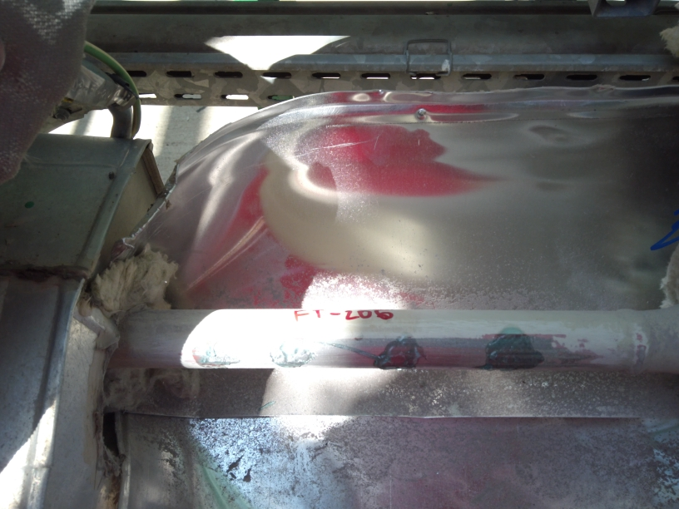  A1-2102-FT-206  Photo 1 | 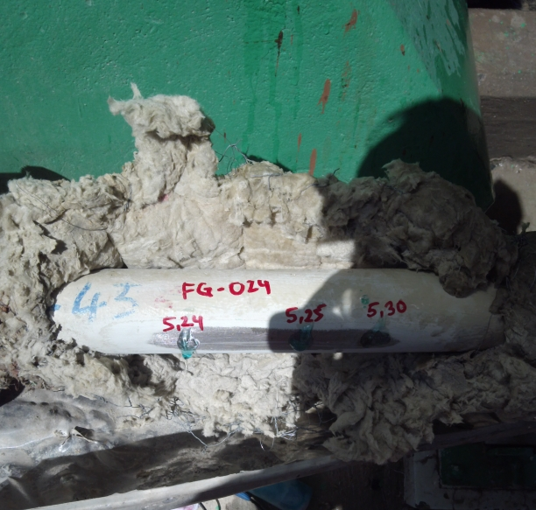  A1-2102-FG-024  Photo 2

Locations | DIA(Ø), inch | Remarks | Result, mm
Locations | DIA(Ø), inch | Remarks | 1 | 2 | 3 | 4
A1-2102-FT-206 | 2’’ | Photo-1 | 4.30 | 4.20 | 4.30 | 4.25
A1-2102-FG-024 | 2’’ | Photo-2 | 5.24 | 5.25 | 5.30 | -

Examined by  UT L II cert. No 13180-2018-00 exp. date:11.07.2023 | Name: Ongarbayev Azimbek | Signature:.................................. | Date: 21 July 2019
Approved by  UT L III cert. No 1A123/15  expiry date 29.02.2020 | Name: Shundryk Ihar | Signature: ............................. | Date: 21 July 2019
Client Representative: | Name: …………………………… | Signature: ................................... | Date: ………………………

